PROGRAM...

//program begins...contact manager//

#include<stdio.h>

#include<conio.h>

#include<string.h>

#include<stdlib.h>

#include<dos.h>

struct contact

{ long ph;

char name[20],add[20],email[30];

}list;

char query[20],name[20];

FILE *fp, *ft;

int i,n,ch,l,found;

int main()

{ main:system("cls");

/* ************Main menu *********************** */

printf("\n\t **** Welcome to a0 contact Manager ****");

printf("\n\n\n\t\t\tMAIN MENU\n\t\t=====================\n\t\t[1] Add a new Contact\n\t\t[2] List all Contacts\n\t\t[3] Search for contact\n\t\t[4] Edit a Contact\n\t\t[5] Delete a Contact\n\t\t[0] Exit\n\t\t=================\n\t\t");

printf("Enter the choice:");

scanf("%d",&ch);

switch(ch)

{

case 0:printf("\n\n\t\tAre you sure u want to exit?");

break;

/* *********************add new contacts************ */

case 1: system("cls");

fp=fopen("contact.dll","a");

for (;;){ fflush(stdin);

printf("To exit enter blank space in the name input\nName (Use identical):");

scanf("%[^\n]",&list.name);

if(stricmp(list.name,"")==0 || stricmp(list.name," ")==0)

break;

fflush(stdin);

printf("Phone:");

scanf("%ld",&list.ph);

fflush(stdin);

printf("address:");

scanf("%[^\n]",&list.add);

fflush(stdin);

printf("email address:");

gets(list.email);

printf("\n");

fwrite(&list,sizeof(list),1,fp);

}

fclose(fp);

break;

/* *********************list of contacts************************* */

case 2:system("cls");

printf("\n\t\t================================\n\t\t\tLIST OF CONTACTS\n\t\t==== ============================\n\nName\t\tPhone No\t Address\t\tE-mail ad.\n=== ==============================================================\n\n");

for(i=97;i<=122;i=i+1)

{

fp=fopen("contact.dll","r");

fflush(stdin);

found=0;

while(fread(&list,sizeof(list),1,fp)==1)

{if(list.name[0]==i || list.name[0]==i-32)

{printf("\nName\t: %s\nPhone\t: %ld\nAddress\t: %s\nEmail\t: %s\n",list.name, list.ph,list.add,list.email);

found++;}

}

if(found!=0)

{printf("=========================================================== [%c]- (%d)\n\n",i-32,found);

getch();}

fclose(fp);

}

break;

/* *******************search contacts********************** */

case 3:system("cls");

do{found=0;

printf("\n\n\t..::CONTACT SEARCH\n\t===========================\n\t..::Name of contact to search: ");

fflush(stdin);

scanf("%[^\n]",&query);

l=strlen(query);

fp=fopen("contact.dll","r");

system("cls");

printf("\n\n..::Search result for '%s' \n====================================== =============\n",query);

while(fread(&list,sizeof(list),1,fp)==1)

{for(i=0;i<=l;i++)

name[i]=list.name[i];

name[l]='\0';

if(stricmp(name,query)==0)

{printf("\n..::Name\t: %s\n..::Phone\t: %ld\n..::Address\t: %s\n..::Email\t: %s\n",list.name,list.ph,list.add,list.email);

found++;

if (found%4==0)

{printf("..::Press any key to continue...");

getch();

}

}

}

if(found==0)

printf("\n..::No match found!");

elseprintf("\n..::%d match(s) found!",found);

fclose(fp);

printf("\n ..::Try again?\n\n\t[1] Yes\t\t[0] No\n\t");

scanf("%d",&ch);

}

while(ch==1);

break;

/* *********************edit contacts************************/

case 4:system("cls");

fp=fopen("contact.dll","r");

ft=fopen("temp.dat","w");

fflush(stdin);

printf("..::Edit contacts======\n\n\t..::Enter the name of contact to edit:");

scanf("%[^\n]",name);

while(fread(&list,sizeof(list),1,fp)==1)

{if(stricmp(name,list.name)!=0)

fwrite(&list,sizeof(list),1,ft);

}

fflush(stdin);

printf("\n\n..::Editing '%s'\n\n",name);

printf("..::Name(Use identical):");

scanf("%[^\n]",&list.name);

fflush(stdin);

printf("..::Phone:");

scanf("%ld",&list.ph);

fflush(stdin);

printf("..::address:");

scanf("%[^\n]",&list.add);

fflush(stdin);

printf("..::email address:");

gets(list.email);

printf("\n");

fwrite(&list,sizeof(list),1,ft);

fclose(fp);

fclose(ft);

remove("contact.dll");

rename("temp.dat","contact.dll");

break;

/* ********************delete contacts**********************/

case 5:system("cls");

fflush(stdin);

printf("\n\n\t..::DELETE CONTACT\n\t==========================\n\t..::Enter the name of contact to delete:");scanf("%[^\n]",&name);

fp=fopen("contact.dll","r");

ft=fopen("temp.dat","w");

while(fread(&list,sizeof(list),1,fp)!=0)

if (stricmp(name,list.name)!=0)

fwrite(&list,sizeof(list),1,ft);

fclose(fp);

fclose(ft);

remove("contact.dll");

rename("temp.dat","contact.dll");

break;

default:printf("Invalid choice");

break;

}

printf("\n\n\n..::Enter the Choice:\n\n\t[1] Main Menu\t\t[0] Exit\n");

scanf("%d",&ch);

switch (ch)

{ case 1:goto main;

case 0:break;

default:printf("Invalid choice");

break;

}

return 0;

}

OUTPUT...

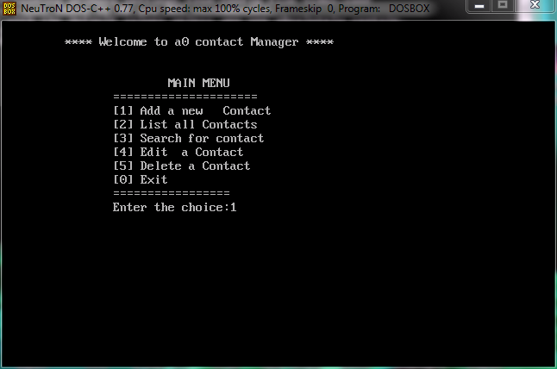

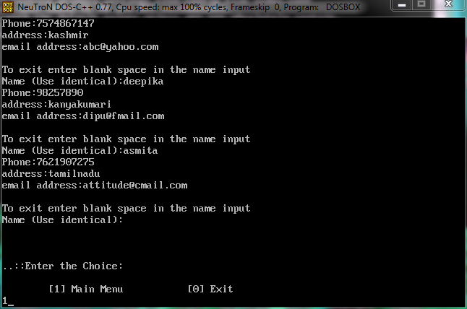

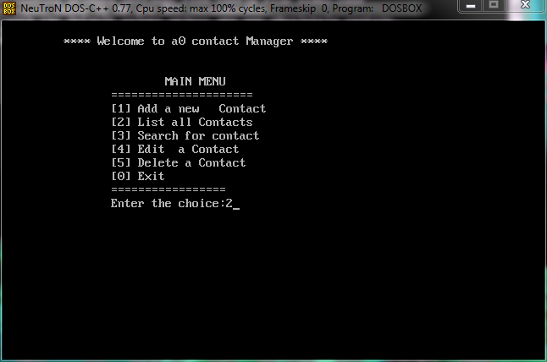

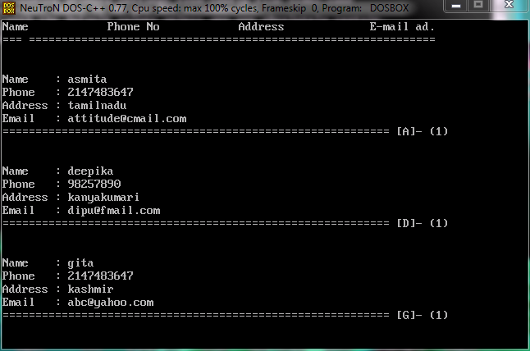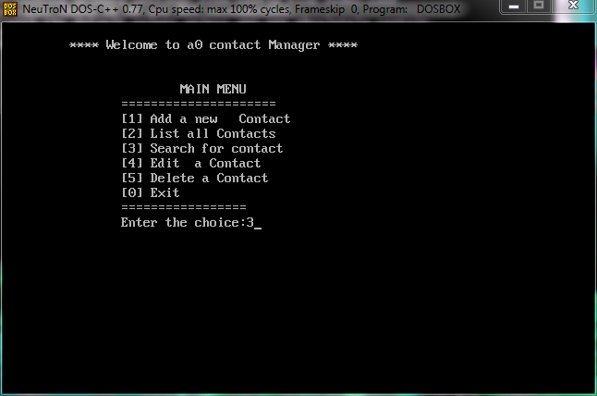

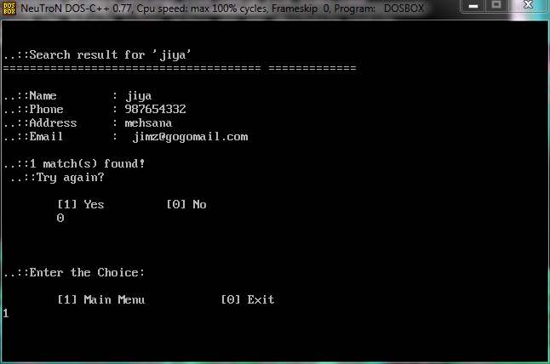

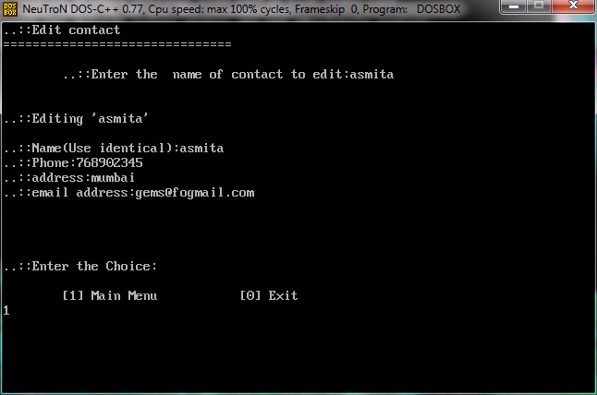

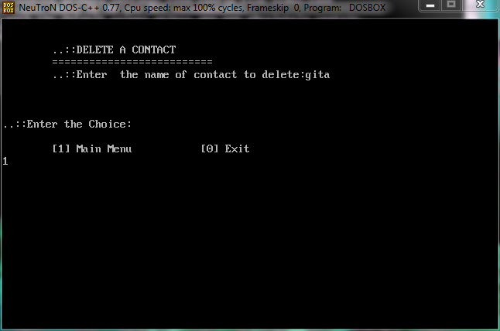

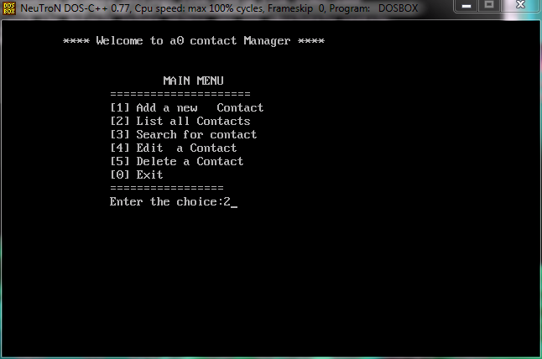

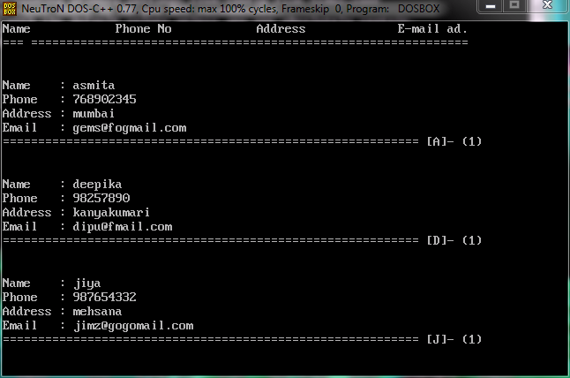

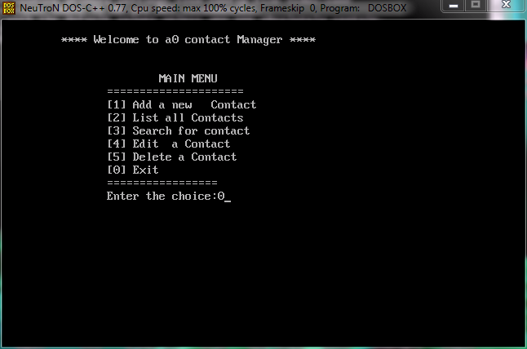

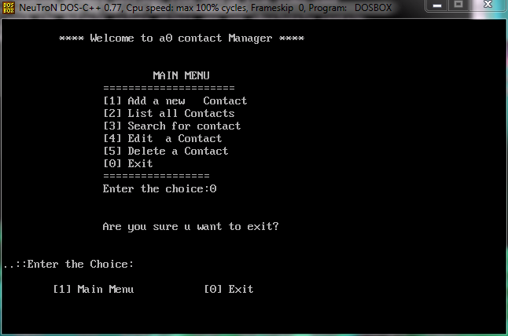

G.H PATEL COLLEGE OF ENGINEERING AND TECHNOLOGY

PROJECT

ON

**CONTACT MANAGER**

COMBINED EFFORTS BY:

VAIBHAVI LAKHANI- 160110107058

NARSINGANI AMISHA-160110107031

Contact manager...

Contact manager is a simple mini project code in c. This is similar to contact manager in mobile phones. You can add contacts remove contacts, edit contacts, search contacts and view all contacts. Graphics is not used jus a console application suitable for beginners. Contact managers help users seamlessly coordinate and handle all prospects, contacts and customer data from a single application. Sophisticated contact managers help users monitor tasks with automated reminders. Calendar functions are often included for tracking time-related data and information.

We have used the structure to initialize the data type to variables to be used in the main() function. It is a menu-driven program that uses switch cases to take input according to the user.

Program also includes the concept of file handling. File pointers have been used to open the dll file in append mode when user wants to add contacts, in read mode when user wants to see all contact in alphabetical order in contact list and in write mode to edit the contacts.

Contact managers provide various features and benefits, including:

* Centralized database of contact information
* Ready-to-use database with search functionality
* Email integration
* Organizing of meetings and appointments
* Address management
* Records and discussion management
* Customizable fields

HEADER FILES INCLUDED AND ITS SIGNIFICANCE:

* **#include<stdio.h>-**printf() is a standard output function.  
  scanf() is a standard input function.  
  **#include<conio.h>**-this is used for the functions like getch,clrscr,gotoxy,etc.
* **#include<string.h>**-this header files contains the header files like strcmp(),strcat(),strcpy(),strlen(),strncpy(),etc.
* **#include<stdlib.h>**-this includes certain macros and functions like exit(), etc.
* **#include<dos.h>-**it contains the function for handling interrupts’, date and time functions i.e.:-delay(), etc.

ADVANTAGE OF CONTACT MANAGER

* Contact manager is a valuable tool for business wanting to integrate their entire business. It helps to manage the contacts and therefore communication for the same.
* It is organized and efficient. It helps us to perform various actions on the contact details such as add,delete,search,edit,etc.

**ACKNOWLEDGEMENTS**

We are pleased to acknowledge prof. Hetal and prof. Khyati for their invaluable guidance during the course of this project work.

We would also like to thanks Dr. Himanshu soni for their allowance of this project.

Vaibhavi lakhani-160110107058

Narsingani amisha-160110107031